1. SALARY CALCULATION

import java.util.Scanner;

public class basic_salary {

public static void main(String[] args) {

Scanner scanner = new Scanner(System.in);

System.out.print("Enter hourly wage: ");

double hourlyWage = scanner.nextDouble();

System.out.print("Enter hours worked per week: ");

int hoursWorkedPerWeek = scanner.nextInt();

System.out.print("Enter number of weeks worked: ");

int weeksWorked = scanner.nextInt();

if (hourlyWage < 0 || hoursWorkedPerWeek < 0 || weeksWorked < 0) {

System.out.println("Invalid input: Values cannot be negative.");

return;

}

double weeklySalary = 0;

if (hoursWorkedPerWeek > 40) {

// Calculate overtime pay

int regularHours = 40;

int overtimeHours = hoursWorkedPerWeek - regularHours;

weeklySalary = (regularHours * hourlyWage) + (overtimeHours * hourlyWage * 1.5);

} else {

weeklySalary = hoursWorkedPerWeek * hourlyWage;

}

if (hoursWorkedPerWeek < 20) {

weeklySalary *= 0.9;

}

double totalSalary = weeklySalary * weeksWorked;

System.out.printf("Total salary is %.1f%n", totalSalary);

scanner.close();

}

}

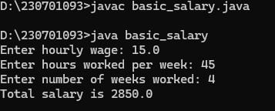

2. TICKET CALCULATION

import java.util.Scanner;

public class Ticketprice1 {

public static void main(String[] args) {

Scanner scanner = new Scanner(System.in);

System.out.print("Enter ticket type (Regular, VIP, Premium): ");

String ticketType = scanner.nextLine().trim();

System.out.print("Enter number of tickets bought: ");

int numberOfTickets = scanner.nextInt();

if (numberOfTickets < 0) {

System.out.println("Invalid input: Number of tickets cannot be negative.");

return;

}

double ticketPrice = 0;

double discount = 0;

switch (ticketType) {

case "Regular":

ticketPrice = 50;

if (numberOfTickets > 10) {

discount = 0.10; // 10% discount

}

break;

case "VIP":

ticketPrice = 100;

if (numberOfTickets > 5) {

discount = 0.15; // 15% discount

}

break;

case "Premium":

ticketPrice = 150;

if (numberOfTickets > 3) {

discount = 0.20; // 20% discount

}

break;

default:

System.out.println("Invalid ticket type.");

return;

}

double baseCost = ticketPrice * numberOfTickets;

double totalCost = baseCost - (baseCost * discount);

if (baseCost < 200) {

totalCost += 20;

}

System.out.printf("Total cost is %.1f%n", totalCost);

scanner.close();

}

}

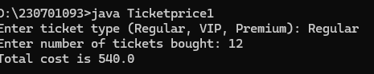

3.LARGEST AND SMALLEST

import java.util.*;

public class Smallarge {

public static void main (String[] args){

Scanner s=new Scanner(System.in);

int n;

n=s.nextInt();

int m =0,largest,smallest;

largest=m;

smallest = 10-1;

while(n!=0){

m=n%10;

if(m>largest)

largest=m;

if(m<smallest)

smallest=m;

n=n/10;}

System.out.println(largest+" "+smallest);

}

}

4. import java.util.Scanner;

class Triangle {

public static void main(String[] args) {

Scanner a = new Scanner(System.in);

int b = a.nextInt();

for (int i = b; i >=0; i--) {

for (int j = b; j>=i; j--) {

if ((i + j) % 2 == 0) {

System.out.print("1 ");

} else {

System.out.print("0 ");

}

}

System.out.println();

} a.close();

}

}

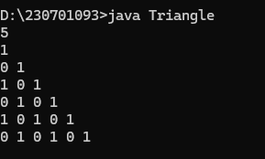

1.4(b)

import java.util.Scanner;

class Triangle2 {

public static void main(String[] args) {

Scanner a = new Scanner(System.in);

int b = a.nextInt();

for (int i = b; i >=0; i--) {

for (int j = 1; j<=i; j++)

System.out.print(j +" ")}

System.out.println();

}

}

}

1.5

import java .util.*;

class Day{

public static void main(String[]args){

Scanner scan=new Scanner(System.in);

String day=scan.nextLine();

switch(day.toLowerCase()){

case "monday":

case "tuesday":

case "wednesday":

case "thursday":

case "friday":

System.out.println(day+" is a weekday.");

break;

case "saturday":

case "sunday":

System.out.println(day+" is a weekend.");

break;

}

}

}

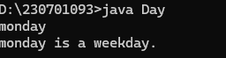

1.6

import java.util.*;

class StrongNumber{

public static void main(String[]args){

int num;

Scanner scan=new Scanner(System.in);

num=scan.nextInt();

int i,fac,sum=0,digit;

int temp=num;

while(temp!=0){

i=1;

fac=1;

digit=temp%10;

while(i<=digit){

fac=fac*i;

i++;

}

sum=sum+fac;

temp=temp/10;

}

if(sum==num) System.out.println(num+" is a Strong number.");

else System.out.println(num+" is not a Strong number.");

}

}

